OBJECTIVES

- To gain knowledge (basic functionality and usability) of hardware components we use daily to interact with computer system.
- To understand the installation and interaction with operating system and various system applications.

INTRODUCTION

This lab aims to enable to student to gain basic knowledge of computer hardware as well as software. In the first lab, basic knowledge regarding hardware and software of the computer is taught i.e., Input/ Output devices, working of motherboard and hard disks and operating systems, Graphic user Interface etc. In the next labs Microsoft office is thoroughly covered. In which students explore different applications of Microsoft Word, Excel, and PowerPoint. In the last labs, C++ and MATLAB programming is covered.

SOFTWARE TOOLS/APPLICATIONS

- Microsoft Word
- Microsoft Excel
- Microsoft PowerPoint
- Dev C++
- MATLABs

EFFECTIVENESS
After completion of the lab, the students will be equipped with the skills and knowledge to interact and use computer effectively. Students will be able to write reports with proper referencing and citations and to design professional Curriculum Vitae and Presentations. They will also be able to use different functions and formulas in MS Excel, Moreover, students will be able to write basic programs in C++ and MATLAB programming languages using Dev C++ and MATLAB software respectively.

Introduction to Information and Communication Technologies

Department of electrical engineering national university of modern languages Islamabad.

LAB OUTLINE

Labs # | Introduction to Information and Communication Technologies
1 | Introduction to computer hardware and system information  - To provide basic knowledge of Computer and its Hardware Devices. Visually learning method is adopted by conducting practical Labs.
2 | GUI operating system and File extensions  - To become familiar with Graphical user Interface, Operating systems and different file extensions.
3 | Working of Hard disk and motherboard components.  - To become familiar with the internal working of Hard disk and motherboard components.
4 | Learning of different functions of Microsoft Word (Home Tab, Insert Tab, Tables).  - To become familiar with different functions of word processing software Microsoft word.
5 | Learning of different functions of Microsoft Word (Headers, Footers, Shapes, layout, Review).  - To become familiar with different functions of word processing software Microsoft word.
6 | Learning of different functions of Microsoft Word (Design Tab, References Tab)  - To become familiar with different functions of word processing software Microsoft word.
7 | Learning to design a professional Curriculum Vitae in Microsoft word.  - To become familiar of different designing tools in MS word so that students should be able to design their CVs in MS word.
8 | Exploration of different functions of Microsoft Excel.  - The objective of the lab is to become familiar with different common tools used in Microsoft Excel.
9 | Open-Ended
10 | Introduction to Microsoft PowerPoint and Presentations designing.  - Objective of this lab is to learn different functions of Power point.
11 | Introduction to DEV C++ software and C++ programming language.  - Objective of the lab is to become familiar with different components, and syntax of C++ language and to learn how to use Microsoft visual studio for C++ programming.
12 | C++ language program writing in DEV C++ software.  - The objective of the lab is to become familiar with the C++ programming language and study of different environments for C++ programming.
13 | Introduction to MATLAB Environment.  - To become familiar with MATLAB interface and syntax of code.
14 | Writing basic programs in MATLAB.  - To gain knowledge of writing simple programs in MATLAB.

Experiment No-01: Introduction to computer hardware and system information

OBJECTIVE
To provide basic knowledge of Computer and its Hardware Devices. Visually learning method is adopted by conducting practical Labs.

INTRODUCTION

INPUT DEVICES
An input device is any peripheral (piece of computer hardware equipment) used to provide data and control signals to an information processing system such as a computer or other information appliance

TYPES OF INPUT DEVICES:

Mouse, Joystick, Keyboard and Scanner etc.

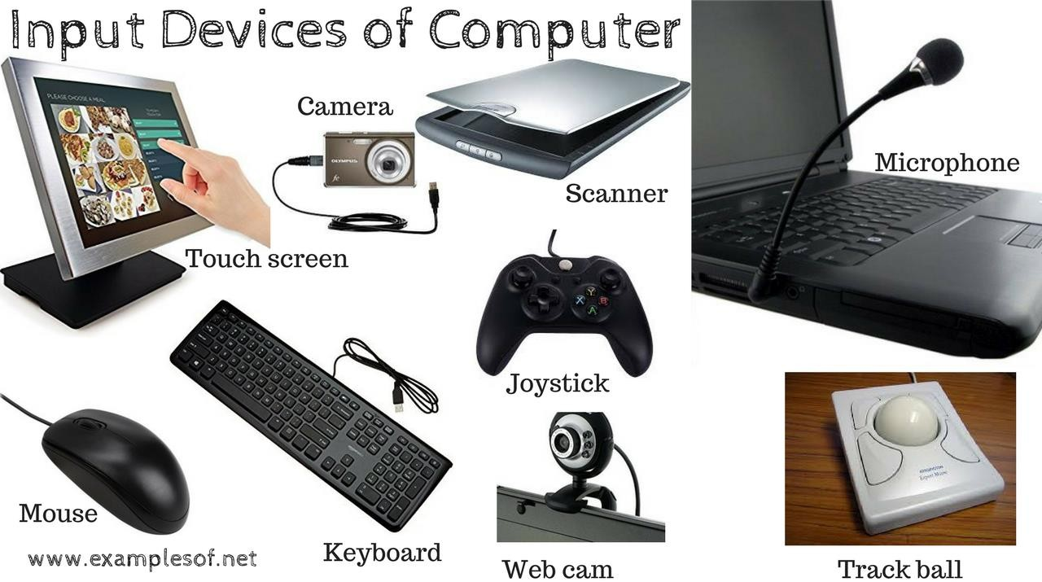
Figure 1. Input Devices of Computer

OUTPUT DEVICES:
An output device is any piece of computer hardware equipment used to communicate the results of data processing carried out by an information processing system (such as a computer) to the outside world.

TYPES OF OUTPUT DEVICES:
Speakers, Headphones, Screen (Monitor), Printer etc.

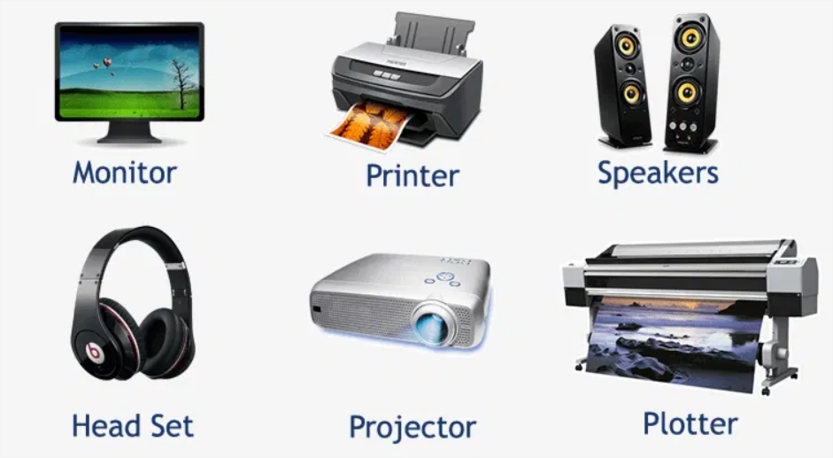
Figure 2. Output Devices

SYSTEM UNITS:
The system unit is the core of a computer system. Usually, it's a rectangular box placed on or underneath your desk. Inside this box are many electronic components that process information. The most important of these components is the central processing unit (CPU), or microprocessor, which acts as the "brain" of your computer.
Another component is random access memory (RAM), which temporarily stores information that the CPU uses while the computer is on. The information stored in RAM is erased when the computer is turned off. Almost every other part of your computer connects to the system unit using cables. The cables plug into specific ports (openings), typically on the back of the system unit. Hardware that is not part of the system unit is sometimes called a peripheral device or devices.

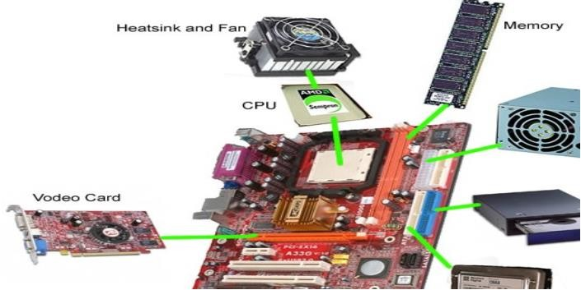

Figure 3. System Units

MOTHERBOARD
In personal computers, a motherboard is the central printed circuit board (PCB) in many modern computers and holds many of the crucial components of the system, providing connectors for other peripherals. The motherboard is sometimes alternatively known as the main board, system board, or, on Apple computers, the logic board.
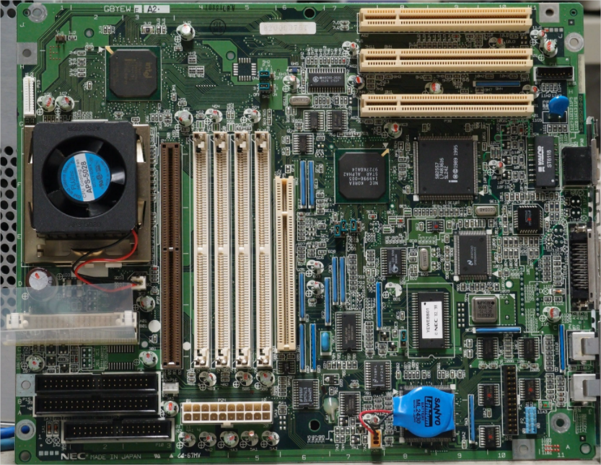

Figure 4. Motherboard

PORTS AND SLOTS
In the easiest to understand terms, "ports" are holes used to plug external devices into your computer. They will be found largely in the back of the computer. "Slots" are holes used to plug internal devices (sound/video cards...etc.) into your computer. These will be found on the inside of your computer and the devices you plug into the will have "ports" on them...which will be able to be accessed from the back of the computer like the other ones. The most common "slots" that you will find inside the computer are as follows: ISA (Industry Standard Architecture): This slot is obsolete, and you probably won’t find it on any computer newer than 5 years old. It is the longest of the slots, a usually colored black. PCI (Peripheral Component Interface): The most common slot. It is the second to the smallest slot, and is the most widely used slot, being smaller, and faster than ISA. It is typically colored white. AGP (Accelerated Graphics Port): This usually "light brown" colored slot is used almost exclusively for video cards. It is quite a bit faster than PCI, with a larger data path, making it perfect for data rich video/graphics. You'll find one of these slots on just about any computer 5 years old or newer.

SERIAL PORT
Serial ports transmit data one bit at a time. Typically, on older PCs, a modem, mouse, or keyboard would be connected via serial ports. Serial cables are cheaper to make than parallel cables and easier to shield from interference.

PARALLEL PORT
The parallel port of older PCs could transmit 8 bits of data at a time, so it was faster than the old serial port (just as more traffic can move along a multi-lane highway than can move along a one- lane road). The parallel port was typically used to connect a printer to the computer.

USB PORT
USB (Universal Serial Bus) is a newer type of serial connection that is much faster than the old serial ports. USB is also much smarter and more versatile since it allows the “daisy chaining” of up to 127 USB peripherals connected to one port. USB ports can support the connection of many kinds of devices (keyboard, mouse, printer, audio in/out, external floppy or Zip drives, scanner, flash drive, etc.). Newer PCs and Macs include several USB ports, some often located in handy spots on the front panel of the computer case or the side of the keyboard. USB connections are hot-swappable (they can be connected and disconnected while the devices are turned on; this is not always true for older connection methods). An updated version, called USB 2.0 has a speed of 480 Mb/sec, which is 40 times faster than the older USB port’s high-speed mode (the connectors look the same). USB 3.0 is the third major version of the Universal Serial Bus (USB) standard for interfacing computers and electronic devices. Among other improvements, USB 3.0 adds the new transfer mode super Speed (SS) that can transfer data at up to 5 Gbit/s (625 MB/s), which is about ten times faster than the USB 2.0 standard. USB 3.0 connectors are usually distinguished from their USB 2.0 counterparts by blue color coding of the receptacles and plugs, and the initials SS.

STORAGE DEVICES
Your computer has one or more disk drives—devices that store information on a metal or plastic disk. The disk preserves the information even when your computer is turned off.

HARD DISK DRIVE
Your computer's hard disk drive stores information on a hard disk, a rigid platter or stack of platters with a magnetic surface. Because hard disks can hold massive amounts of information, they usually serve as your computer's primary means of storage, holding almost all of your programs and files. The hard disk drive is normally located inside the system unit.
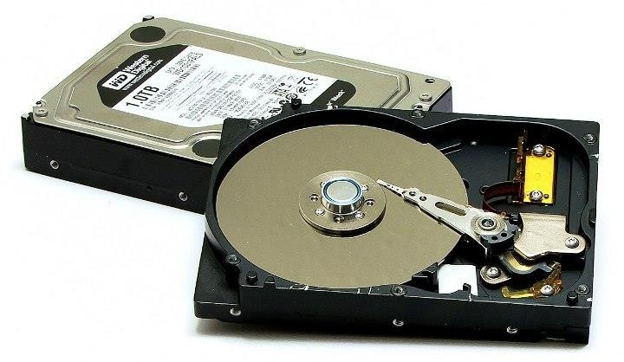

Figure 5. Hard Disk

SOLID STATE DRIVES
A solid-state drive (SSD) is a solid-state storage device that uses integrated circuit assemblies as memory to store data persistently. SSDs have no moving (mechanical) components. This distinguishes them from traditional electromechanical magnetic disks such as hard disk drives (HDDs) or floppy disks, which contain spinning disks and movable read/write heads. Compared with electromechanical disks, SSDs are typically more resistant to physical shock, run silently, have lower access time, and less latency. However, while the price of SSDs has continued to decline over time, consumer-grade SSDs are still roughly six to seven times more expensive per unit of storage than consumer-grade HDDs. As of 2014, most SSDs use NAND-based flash memory, which retains data without power. For applications requiring fast access, but not necessarily data persistence after power loss, SSDs may be constructed from random-access memory (RAM). Such devices may employ separate power sources, such as batteries, to maintain data after power loss. Hybrid drives or solid-state hybrid drives (SSHDs) combine the features of SSDs and HDDs in the same unit, containing a large hard disk drive and an SSD cache to improve performance of frequently accessed data.

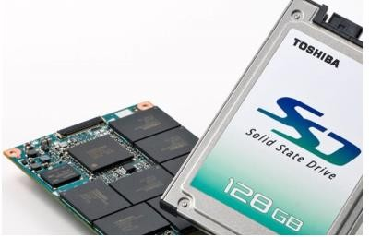
Figure 6. SSD

CD AND DVD DRIVES
Nearly all computers today come equipped with a CD or DVD drive, usually located on the front of the system unit. CD drives use lasers to read (retrieve) data from a CD, and many CD drives can also write (record) data onto CDs. If you have a recordable disk drive, you can store copies of your files on blank CDs. You can also use a CD drive to play music CDs on your computer.

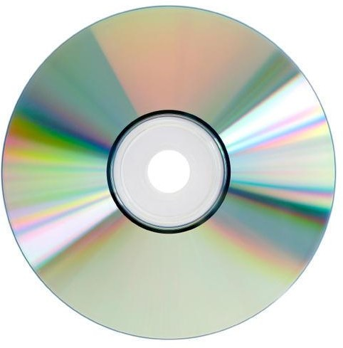

Figure 7. Compact Disk
DVD drives can do everything that CD drives can, plus read DVDs. If you have a DVD drive, you can watch movies on your computer. Many DVD drives can record data onto blank DVDs. If you have a recordable CD or DVD drive, periodically back up (copy) your important files to CDs or DVDs. That way, if your hard disk ever fails, you won't lose your data.

FLOPPY DISK DRIVES
Floppy disk drives store information on floppy disks, also called floppies or diskettes. Compared to CDs and DVDs, floppy disks can store only a small amount of data. They also retrieve information more slowly and are more prone to damage. For these reasons, floppy disk drives are less popular than they used to be, although some computers still include them.
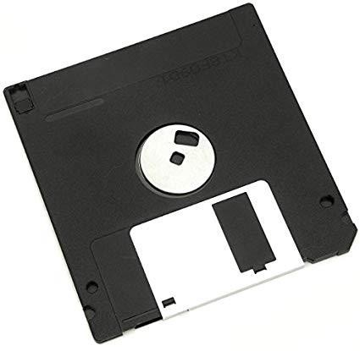

Figure 8. Floppy Disk

COMMUNICATION DEVICES
Computers can communicate (To transfer information from one computer to another) with the other computer by forming networks (with the help of different communication devices).

MODEM
To connect your computer to the Internet, you need a modem. A modem is a device that sends and receives computer information over a telephone line or high-speed cable. Modems are sometimes built into the system unit, but higher-speed modems are usually separate components.

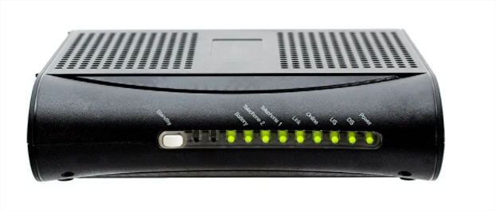

Figure 9. Modem
NIC ADAPTERS:
NIC is Network Interface Card; this is the most important device in building network. These adapters are the most common part of computers which are used in our homes and offices. Nic is also referred to LAN, i.e., is Local area network card. Communication mediums (cables) are attached to this card to build network. This device has unique Mac address. To build network unique IP address is assign to this LAN card to begun communication. In case of developing WLAN, instead of LAN card we use Wireless card. Its functionality is same as simple LAN card; it is just wireless communication device which connects to router for communication.
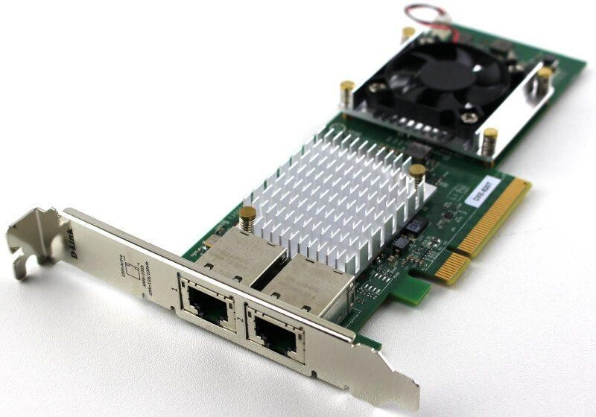

Figure 10. NIC adapter

ROUTERS
Router is intelligent device which routes data to destination computers. It helps in connecting two different logical and physical networks together. In small network server is connected to router along with clients for communication. With routers network communication is not possible; it is soul of network without which distribution if internet and other network data to entire network is impossible.
It works very same when it comes to use wireless network using wireless network router. It performs all functions similarly without using any medium like cables etc. Router uses software known as routing table. Routing table is used to store source and destination address. Major companies which know for manufacturing routers and wireless routers are TP Link, Cisco Systems, Nortel, D link etc.

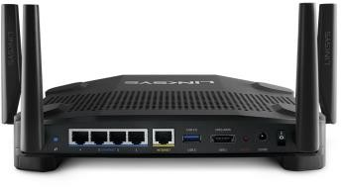

Figure 11. Router
SWITCHES
Switch is another important device when we talk about computer network on broader spectrum. It is used at the same place as hub is but the only difference between the two is that switch possess switching table with in it. Switching tables store the MAC addresses of every computer it is connected to and send the data to only request address unlike hub which broadcasts the data too all the ports. Switches can be considered advance form of hubs.
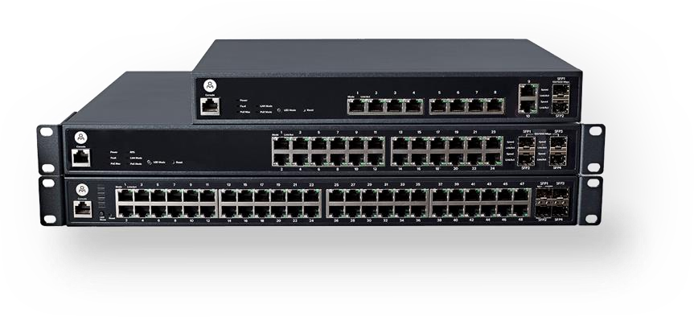
Figure 12. Switches

FIREWALL
As name suggests it passing through to something. Firewall device connects LAN with internet. Its basic functionality is to provide security to the network. By using firewall incoming out going traffic can be monitored for any malicious activity within the network which can be harmful to network integrity.
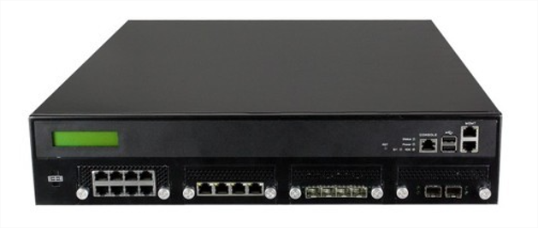
Figure 13. Firewall

`

TASK:

State the difference between HDD, SSD and NVMe.

State the difference between a CPU, GPU and TPU.

Does the Mac of two routers can be same?

Does the local IP (private IP) of two different LANs can be same?

Conclusion

